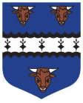**19TH September 2020 AT GLENMONA HOUSE, CUSHENDUN**

**TICKETS £100 PER PERSON, TABLES OF 10**

**As with previous events in 2004 and 2017, we expect this event to sell out quickly, therefore early booking is essential to avoid disappointment.**

**Committee members will be available in Mc Brides each Thursday from 8.30 -9.30 pm to accept bookings/payments/discuss payment plans.**